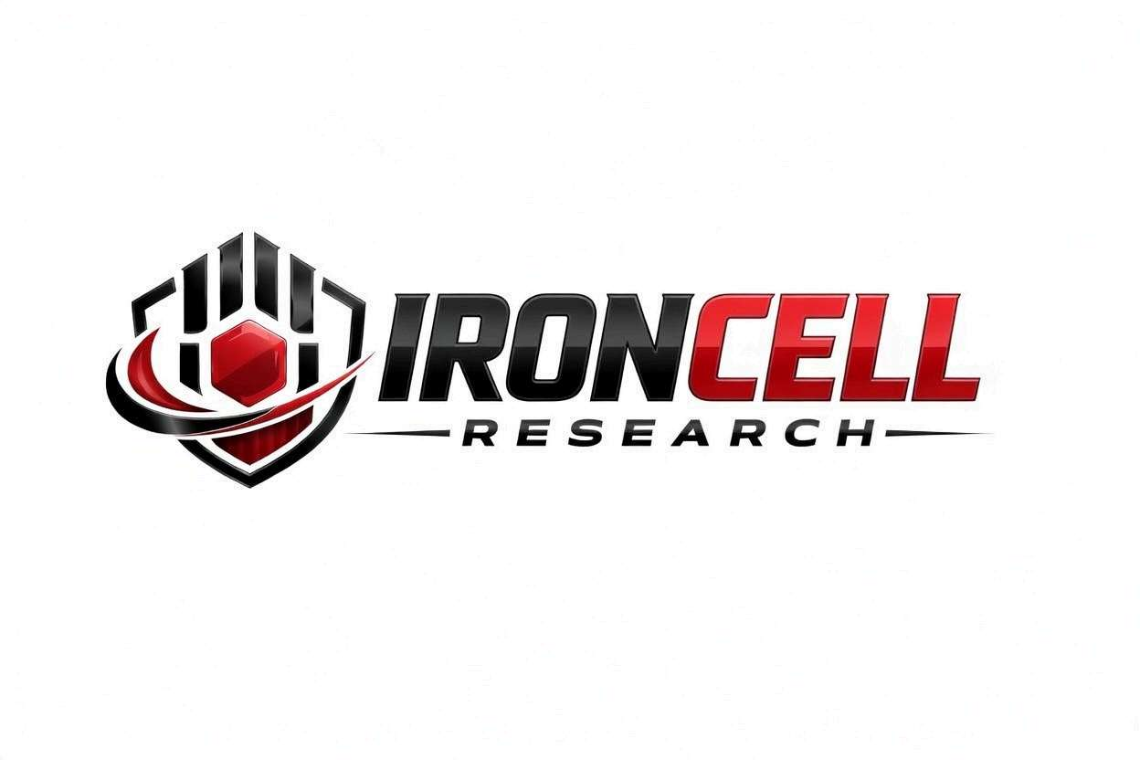
PEPTIDE RESEARCH BRIEF
GLOW
Tri-Peptide Regenerative Blend | BPC-157 + TB-500 + GHK-Cu (70mg)

Description, Benefits, Dosage & Research Overview

Iron Cell Research
IronCellResearch.com
For Research Use Only


Blend Overview
Blend Name | GLOW
Classification | Regenerative Tri-Peptide Blend (70mg total)
Components | BPC-157 (Body Protection Compound) + TB-500 (Thymosin Beta-4 Fragment) + GHK-Cu (Copper Tripeptide-1)
Research Focus | Tissue repair, regeneration, collagen synthesis, anti-inflammatory
Purity | Greater than or equal to 99% HPLC (each component)
Storage | Lyophilized, -20C, protected from light
Research Status | Active preclinical research (individual components and blend)

Description
GLOW combines three of the most-researched regenerative peptides into a single 70 mg blend. BPC-157 (Body Protection Compound, 15 amino acids) is derived from human gastric juice and is studied for tissue-protective and healing properties. TB-500 is the active fragment (amino acids 17-23) of Thymosin Beta-4, involved in cell migration and tissue repair. GHK-Cu (glycyl-L-histidyl-L-lysine bound to Cu²⁺) is a naturally occurring copper-tripeptide that supports collagen production, skin remodeling, and wound healing.
Together, these three peptides act on complementary mechanisms — angiogenesis, cell migration, collagen synthesis, and anti-inflammatory signaling — providing broader regenerative coverage than any single component alone.

Component 1: BPC-157
Full Name | Body Protection Compound-157
Sequence | Gly-Glu-Pro-Pro-Pro-Gly-Lys-Pro-Ala-Asp-Asp-Ala-Gly-Leu-Val
Molecular Weight | 1419.53 g/mol
CAS Number | 137525-51-0
Origin | Derived from human gastric juice
Stability | Stable in gastric juice (unique among peptides)

BPC-157 Mechanisms
BPC-157 promotes angiogenesis through upregulation of VEGF and FGF-2, modulates the nitric oxide (NO) system for vascular and tissue protection, upregulates growth factor receptors including EGF and HGF, and directly stimulates tendon fibroblast outgrowth for tendon and ligament healing.

Component 2: TB-500
Full Name | Thymosin Beta-4 Fragment (amino acids 17-23)
Sequence | LKKTETQ
Molecular Weight | 846.93 g/mol
Origin | Active fragment of Thymosin Beta-4
Biological Half-Life | Approximately 2 hours

TB-500 Mechanisms
TB-500 sequesters G-actin monomers to promote cell migration and tissue repair, reduces inflammation through downregulation of pro-inflammatory cytokines, promotes angiogenesis and new blood vessel formation, and activates hair follicle stem cell migration for wound healing.

Component 3: GHK-Cu
Full Name: Glycyl-L-Histidyl-L-Lysine Copper Complex (Copper Tripeptide-1)
Sequence: Gly-His-Lys (3 amino acids) + Cu²⁺
Molecular Weight: 340.84 g/mol (copper-bound complex)
Origin: Naturally occurring copper-binding tripeptide; declines with age in human plasma

GHK-Cu Mechanisms
GHK-Cu binds copper ions and modulates over 4,000 genes implicated in tissue remodeling. It stimulates collagen, elastin, and glycosaminoglycan synthesis in dermal fibroblasts, supports keratinocyte proliferation, and exerts antioxidant and anti-inflammatory effects. The copper ion itself is essential to lysyl oxidase activity required for collagen and elastin cross-linking.

Synergistic Research Benefits

Musculoskeletal Recovery
- Tendon, Ligament & Skin: BPC-157 stimulates fibroblast outgrowth, TB-500 promotes cell migration to injury sites, and GHK-Cu drives collagen synthesis — together supporting comprehensive connective tissue and skin repair.
- Joint Health: Combined anti-inflammatory and regenerative effects across all three peptides support cartilage, synovial, and dermal tissue healing.
- Bone Healing: Complementary angiogenic and growth factor pathways across BPC-157, TB-500, and GHK-Cu may support fracture and bone repair.

Soft Tissue Repair
- Muscle Recovery: TB-500 promotes myocyte migration and differentiation, BPC-157 enhances blood vessel formation for nutrient delivery, and GHK-Cu supports extracellular matrix remodeling — together accelerating muscle recovery.
- Wound Healing: Triple angiogenic and matrix-remodeling pathways accelerate wound closure, scar reduction, and tissue remodeling.

Skin & Anti-Aging
- Collagen & Elastin: GHK-Cu directly stimulates collagen and elastin synthesis in dermal fibroblasts, supporting skin firmness, elasticity, and glow.
- Skin Barrier: Combined effects of BPC-157, TB-500, and GHK-Cu support skin barrier integrity, repair, and overall radiance.

Cardiovascular Support
- Vascular Repair: All three peptides influence angiogenesis through distinct pathways, providing broad coverage for blood vessel formation and repair.
- Cardioprotection: BPC-157 has shown protective effects in cardiac injury models through NO pathway modulation; GHK-Cu has additional cardiovascular research interest related to copper homeostasis.

Dosage & Administration
The following dosage information is provided for research reference purposes only. The GLOW blend is supplied as a single 70 mg vial containing all three components.
Protocol | Dose Range | Route | Frequency
GLOW Standard | 500-1000 mcg | SubQ Injection | Daily
GLOW Maintenance | 250 mcg | SubQ Injection | Daily
GLOW Loading | 2-5 mg | SubQ Injection | 2x per week (4-6 weeks)
GLOW Reduced Frequency | 2 mg | SubQ Injection | 1-2x per week

Reconstitution Guidelines
Solvent | Sterile bacteriostatic water
BAC Water Ratio | 2 mL BAC water per 70mg vial
Resulting Concentration | 2 mL BAC water per 70mg vial
Mixing | Gently swirl, do not shake. Pre-mixed blend; no separate components.
Storage | Refrigerate at 2-8C, use within 21 days
Injection Site | Subcutaneous, rotate sites; may inject near injury site per protocol

Safety Profile
All three components demonstrate favorable safety profiles in preclinical research:
- BPC-157: Excellent safety profile in animal studies with no reported toxic dose identified.
- TB-500: Derived from naturally occurring Thymosin Beta-4; good tolerability with minimal adverse effects in preclinical models.
- Injection Site Reactions: Mild, transient redness or discomfort possible with subcutaneous injection.
- Drug Interactions: No significant drug interactions identified for any component in preclinical research; caution with copper-modulating supplements alongside GHK-Cu.
- Pregnancy & Nursing: Insufficient safety data; use not recommended during pregnancy or lactation.
Long-term human safety data remains limited for all three peptides. Research continues to establish comprehensive safety profiles.

Key References
- Seiwerth S, et al. BPC 157 and Standard Angiogenic Growth Factors: Gastrointestinal Tract Healing, Lessons from Tendon, Ligament, Muscle and Bone Healing. Current Pharmaceutical Design. 2018.
- Chang CH, et al. The Promoting Effect of Pentadecapeptide BPC 157 on Tendon Healing Involves Tendon Outgrowth, Cell Survival, and Cell Migration. Journal of Pharmacological Sciences. 2011.
- Pevec D, et al. Impact of Pentadecapeptide BPC 157 on Muscle Healing Impaired by Systemic Corticosteroid Application. Medical Science Monitor. 2010.
- Pickart L, Margolina A. Regenerative and Protective Actions of the GHK-Cu Peptide in the Light of the New Gene Data. International Journal of Molecular Sciences. 2018;19(7):1987.
- Pickart L. The Human Tripeptide GHK and Tissue Remodeling. Journal of Biomaterials Science Polymer Edition. 2008;19(8):969-988.
- Malinda KM, et al. Thymosin Beta-4 Accelerates Wound Healing. Journal of Investigative Dermatology. 1999.
- Pickart L, et al. GHK Peptide as a Natural Modulator of Multiple Cellular Pathways in Skin Regeneration. BioMed Research International. 2015;2015:648108.
- Smart N, et al. Thymosin Beta-4 Is Essential for Coronary Vessel Development. Annals of the New York Academy of Sciences. 2007.

Contact & Information
Company | Iron Cell Research
Website | IronCellResearch.com
Email | orders@ironcellresearch.com
Product Support | Available via website contact form

Disclaimer
This document is intended for informational and research purposes only. GLOW is sold strictly as a research compound and is not intended for human consumption. The information provided herein does not constitute medical advice, diagnosis, or treatment recommendations. All research applications should comply with applicable institutional, local, and federal regulations. Iron Cell Research makes no claims regarding the therapeutic efficacy of GLOW for any medical condition. Researchers should consult with qualified healthcare professionals and institutional review boards before initiating any research protocols involving human subjects.
Iron Cell Research - For Research Use Only


